EXPERIMENT NO:
AIM: Perform File Transfer and Access using FTP.
TOOLS/SOFTWARES REQUIRED: Cisco Packet tracer
THEORY:
FTP (File Transfer Protocol) is a standard network protocol used to transfer files between a client and a server over a TCP/IP network, such as the Internet or a local network. It allows users to upload, download, rename, delete, and manage files on a remote server.
FTP follows a client–server architecture:
- The FTP client is the system that requests files or sends files.
- The FTP server stores the files and responds to the client’s requests.
FTP uses two separate communication channels:
- Control Connection (Port 21) – Used for sending commands and responses between client and server.
- Data Connection (Port 20) – Used for the actual transfer of files.
To access an FTP server, a user must provide authentication credentials such as a username and password, although some servers allow anonymous login.
FTP supports various operations including:
- Uploading files from client to server
- Downloading files from server to client
- Listing directories
- Renaming or deleting files
- Creating or removing directories
The protocol works over TCP (Transmission Control Protocol) to ensure reliable data transmission. FTP is widely used for website file management, large file transfers, and remote file access.

OUTPUT:
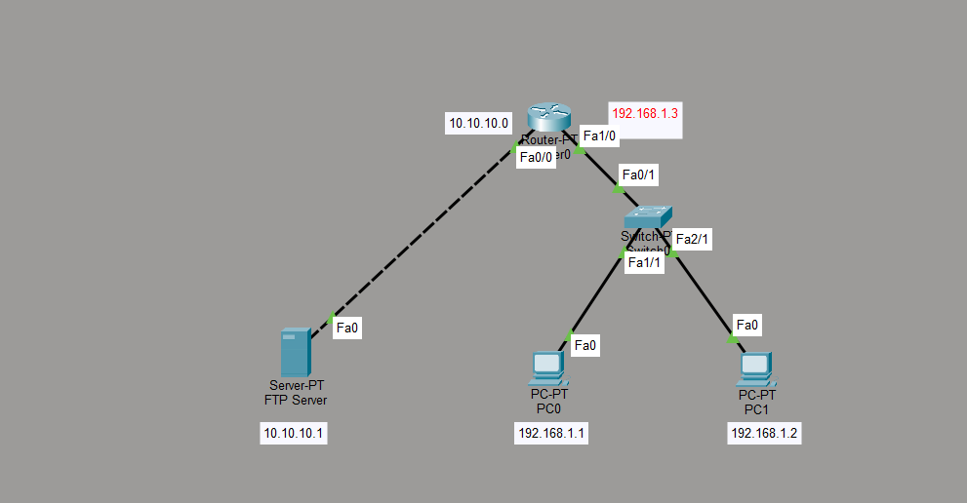
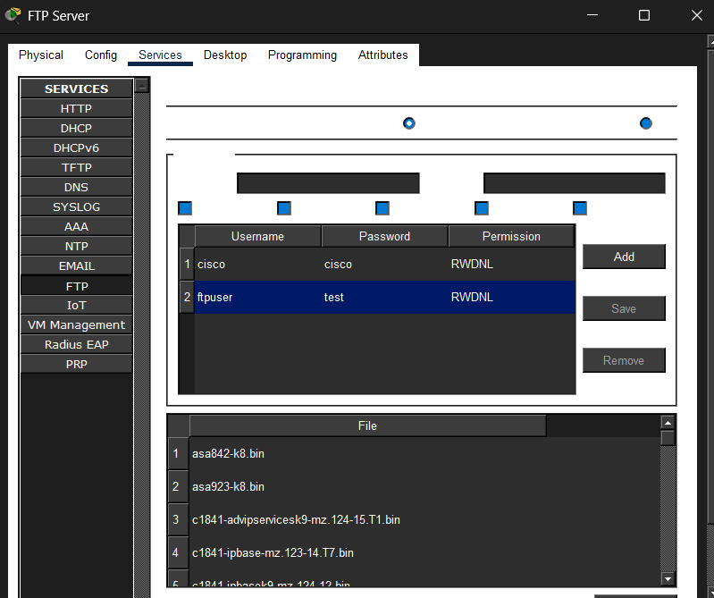
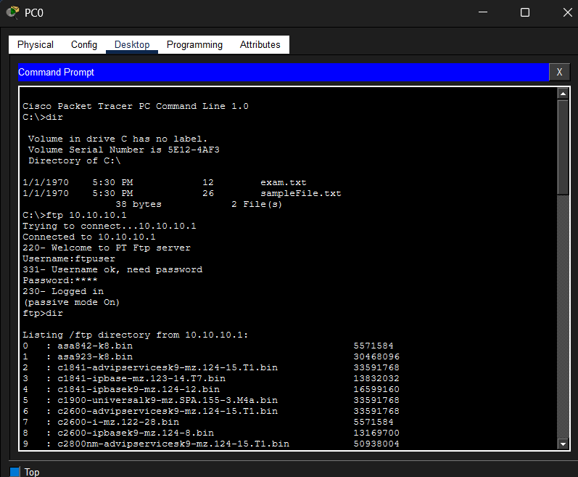

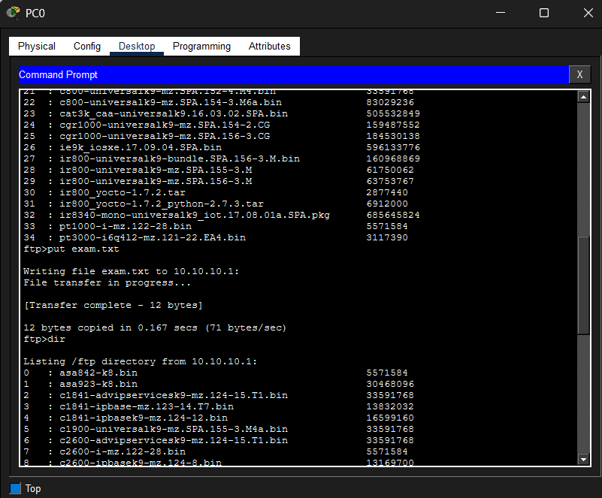
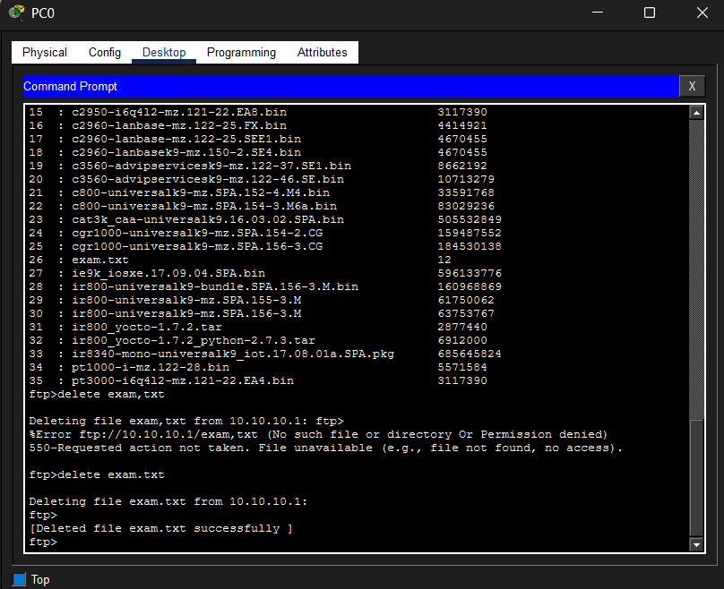
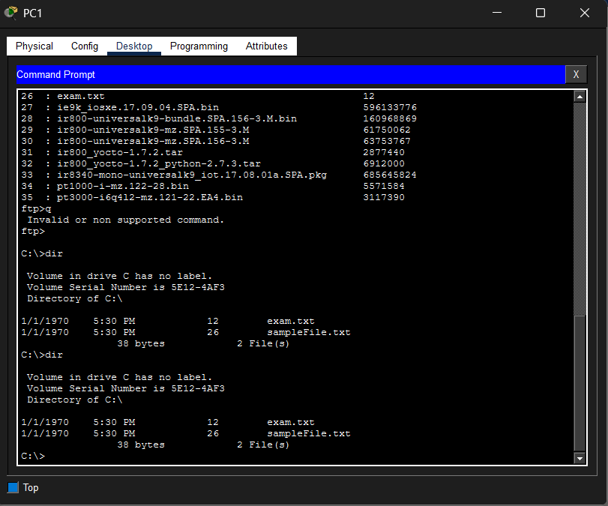
CONCLUSION:
The FTP protocol was successfully used to transfer and access files between a client and a server. This experiment demonstrated how FTP enables uploading, downloading, and managing files over a network, making it a useful protocol for remote file sharing and management.

